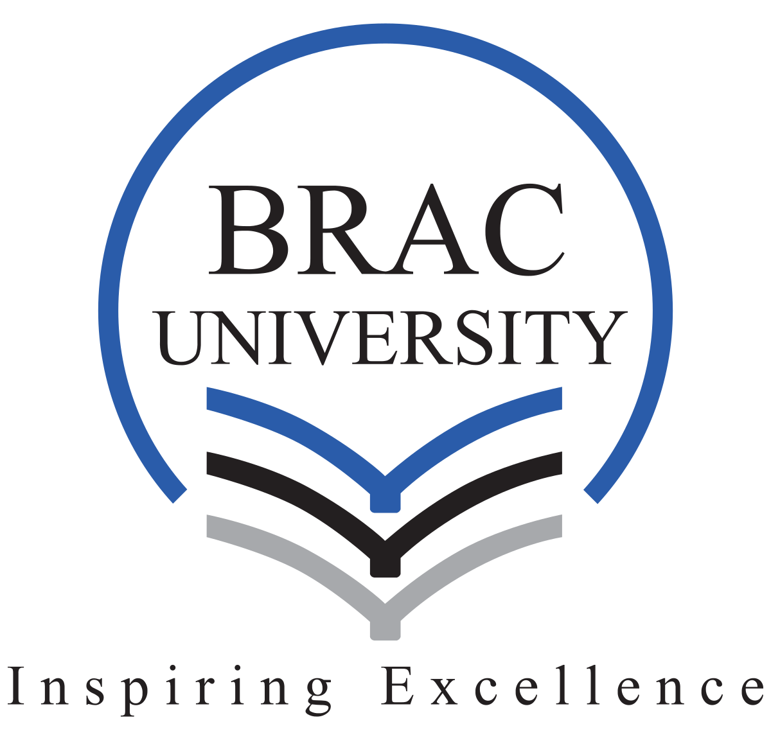

Global Citizenship Reflection Portfolio

CST309: Global Citizenship
Section- 04
Name: Anonna Dev Nipa
ID: 21301191

Submitted to:
Dr. Md Tariqul Islam
September 8, 2025

Personal Reflection:

At the beginning of this course, I viewed citizenship in a very traditional sense, mainly as a legal status. For me, it meant the rights I hold in my country of birth and my duties toward it . I emphasized freedom of expression because I believed that having a voice and being able to use it was the most important part of being a citizen. However,over time, I realized that citizenship, especially global citizenship, goes beyond rights and responsibilities within one nation.

Through readings and discussions, my understanding of global citizenship widened and I came to see it as a responsibility to engage with issues that cross borders. It is about recognizing the struggles of others are connected to my own and addressing them in ways that show solidarity, rather than charity. Learning about migration and statelessness was eye-opening. I realized, as Arendt (1973) highlights, that human rights are fragile without state protection, and the ‘right to have rights’ depends on belonging to a community. A firsthand example would be the Harijan community in Dhaka. Although we live in the same city, their struggles with social stigma and inequality are very different from mine. After talking with a few locals of that community, I became aware of their challenges in accessing proper education and their financial difficulties that prevent them from affording university enrolment for their children. I also learned that they are often unable to secure proper jobs because of not having permanent residence. I was not unaware of these differences and injustice people have to face even when living in the same city. This also shows that global citizenship is not only about distant crises but also about noticing injustice and exclusion within our own local contexts.

Another insight would be Bangladesh’s role in hosting the Rohingya despite being a low-income country itself. Over a million refugees were welcomed which is a strong act of solidarity. But, I recently learned that most refugees worldwide are hosted in low and middle income countries while wealthier nations with far greater resources often do far less. Although richer states taking more responsibility sound fair but at the same time, refugee acceptance is complex. These challenges include economic strain on housing and healthcare, social tension and xenophobia. This situation clearly reflects Haddad’s observation that refugee protection directs to the tension between sovereignty and humanitarian duty (2008).

Group discussions in classes also helped me notice how different impressions my classmates had from mine. Through these experiences, I learned that being a global citizen also means bringing awareness into daily life, making ethical choices, and working with others to create meaningful change.

Cultural Encounter Reflection

A class discussion on justice stood out the most to me as an engaging and meaningful encounter. At first, my personal definition of justice was very simple: getting fair or deserving treatment or punishment based on one’s actions. I thought of justice mainly in terms of individual accountability.

When we were asked to post our definitions of justice on Padlet and then heard some of the ideas being read aloud, including my own, I realized how differently my classmates understood the same concept. Some emphasized dignity, empathy, or equal rights, while others spoke about fairness. One student’s comment that “justice is always subjective” really made me pause because I had never considered fairness as something that could feel different depending on who you are or where you come from. It could vary depending on history, culture, or lived experience. That moment challenged me to realize my view was narrower than I thought.

My realization deepened during the Global Justice Simulation, a class task we had to do in groups, where one member from each group would play the role of a different stakeholder in the fashion industry. There were five stakeholders in total: factory worker, owner, international brand representative, labor rights NGO, and consumer from the Global North. Hearing from these five perspectives individually was striking because none of them were wrong from their perspective. Each stakeholder spoke from their own realities and interests, but the distribution of suffering and benefits was uneven. For example, the factory worker’s concerns were for fair treatment and dignity which sharply contrasted with the brand representative’s focus on profit and market pressure. This exercise made me realize that justice is shaped by power imbalances and structural inequalities. It was an eye-opening way to experience Amartya Sen’s idea that justice is less about imagining a perfectly just society and more about reducing real-world injustices (2009). The whole class seemed to shift at that point, and I found myself rethinking the assumptions I had carried into the room.
From these encounters, what I learned about myself is that I often default to a very legalistic, definition-based way of thinking. I assumed justice could be applied equally to everyone without recognizing how systemic inequality or history shapes people’s experiences. That was a blind spot I only noticed after engaging with my peers. What I learned about others is that cultural and personal experiences shape many definitions in profound ways. There is no single answer that fits everyone. Most importantly, it reminded me how listening to others can shift and broaden my own perspective in ways a textbook could never do.

Global Issue Case Analysis
Forced displacement is one of the most pressing global issues of our time. By the end of 2024, over 123 million people got displaced worldwide due to conflict, persecution, violence, or disasters (UNHCR). Unlike voluntary migration, forced displacement strips people’s choice and security, often leaving them stateless and vulnerable. It exposes the limits of international protection frameworks and highlights deep inequalities in how responsibility is shared globally.
The Rohingya crisis offers one of the most striking examples of this crisis and shows how deeply connected forced displacement and statelessness are.The Rohingya, a Muslim minority from Myanmar’s Rakhine State, were stripped of citizenship under the 1982 Citizenship Law, leaving them stateless. Decades of oppression culminated in mass violence in 2017. Villages were burned, people were killed and sexually violated which led the Rohingya to flee, mainly into neighboring Bangladesh (Barany, 2022). The UN described this as ethical cleansing.
The crisis also reveals how local and global dimensions intersect. Locally, Bangladesh currently hosts nearly one million Rohingya in Cox’s Bazar, one of the world’s largest refugee camps. As a low-income country, Bangladesh has shown extraordinary solidarity, but the strain is undeniable. Hosting such a large population has created pressures on housing, education, and health services, while refugees themselves face restrictions on work, mobility, and formal education (Human Rights Watch, 2018).
Globally,this crisis exposes the gap between humanitarian ideals and political realities. Frameworks like the 1951 Refugee Convention and the Global Compact on Refugees ask states for protection and responsibility-sharing, but enforcement on these frameworks still remains weak. This imbalance reflects what Haddad (2008) identifies as the tension between state sovereignty and humanitarian duty and it now defines the modern refugee politics. Similarly, Arendt (1973) shows that statelessness strips individuals of the “right to have rights,” a reality that the Rohingyas embody.
Addressing forced displacement therefore requires both local support and global action. In the case of the Rohingya, host countries like Bangladesh struggle with severe economic pressures and limited resources , which makes the need for sustained international funding and investment in health, education, and infrastructure essential. Locally, policies could include granting Rohingya children access to certified education, expanding livelihood opportunities such as legal work permits, and improving camp healthcare services, especially for women and girls. Globally, wealthier countries should increase resettlement quotas for Rohingya refugees, ensure accountability for Myanmar’s military through international legal mechanisms, and provide targeted aid that directly supports both refugees and host communities to reduce tensions. Finally, global citizens and policymakers should focus on Amartya Sen’s idea of removing visible injustices such as statelessness and forced displacement rather than waiting for a perfect solution (2009). Immediate steps must be taken to ensure displaced populations gain access to education, healthcare, and dignity.

Global Citizen Action Plan
The aim as a global citizen is to stand in solidarity with displaced and marginalized people, while also taking responsibility in academic, personal, and community contexts.
Action Plan
Goal | Objectives | Actions | Responsibility | Timeline | Evaluation
Academic Engagement | 1. Deepen understanding of forced displacement, statelessness, and justice. | - Write a research paper on forced displacement, migration or justice using ideas from Sen, Arendt and Haddad.  - Attend lectures, conferences, or webinars annually on refugee/migration issues.  - Share insights in class or with peers in study groups or discussions. | Myself | 2025–  2026 | - Completed essays, reflection journal entries  - Feedback from peers
Personal Lifestyle & Growth | 1. Practice ethical living choices and intercultural empathy.  2. Strengthen awareness of global inequalities. | - Shift 50% or more of purchases to brands that are ethical  - Attend intercultural or solidarity events like language clubs, cultural exchanges, and refugee stories. | Myself | Start Oct  2025 (review quarterly) | - Track purchases  - reflections notes after each event
Community & Peer Engagement | 1. Support displaced and marginalized groups locally.  2. Promote peer-to-peer learning | - Volunteer 4-5 hrs per month with NGOs working with refugees e.g., tutoring, language workshops.  - Raise awareness online through social media and digital platforms  - Run one peer-sharing circle on campus to discuss global issues | Myself, peers, NGO partners | Nov 2025 onwards | - Record Volunteering hours  - NGO feedback  - peer attendance
Fig: Action plan table
This action plan shows how I can put global citizenship into action. It is feasible and can be implemented with available resources, such as student groups, campus facilities, nearby NGOs, and digital platforms for raising awareness. However, there are also potential barriers like limited time due to academic pressure, financial constraints for ethical purchases, and the possibility of low peer interest. To address these challenges, I can shift focus toward alternatives such as online storytelling, or peer-learning circles, which will require fewer resources but can still create meaningful impact. Success of this action plan will be measured by evaluating completed tasks, personal reflections and recorded entries. This plan is a roadmap to integrate justice, empathy, and responsibility in my everyday life.

Reference
Arendt, H. (1973). The Decline of the Nation-State and the End of the Rights of Man. In The Origins of Totalitarianism. Harcourt Brace & Company.
Barany, Z. (2022). The Rohingya Predicament.: Why Myanmarʹs Army Gets Away with Ethnic Cleansing. Istituto Affari Internazionali (IAI).
Haddad, E. (2008). The Refugee and the International States System. In The refugee in international society. Between sovereigns. Cambridge University Press.
Human Rights Watch. (2018). Bangladesh: Rohingya refugee crisis update. https://www.hrw.org/news/2018
Sen, A. (2009). Introduction. In The idea of justice. Harvard University Press.
UNHCR. (2025). Global trends: Forced displacement in 2024. United Nations High Commissioner for Refugees.
https://www.unhcr.org/globaltrends

